1. Create two vectors, age and weight respectively of 10 infants as follows

age <- c(1,3,5,2,11,9,3,9,12,3)

weight <- c(4.4,5.3,7.2,5.2,8.5,7.3,6.0,10.4,10.2,6.1)

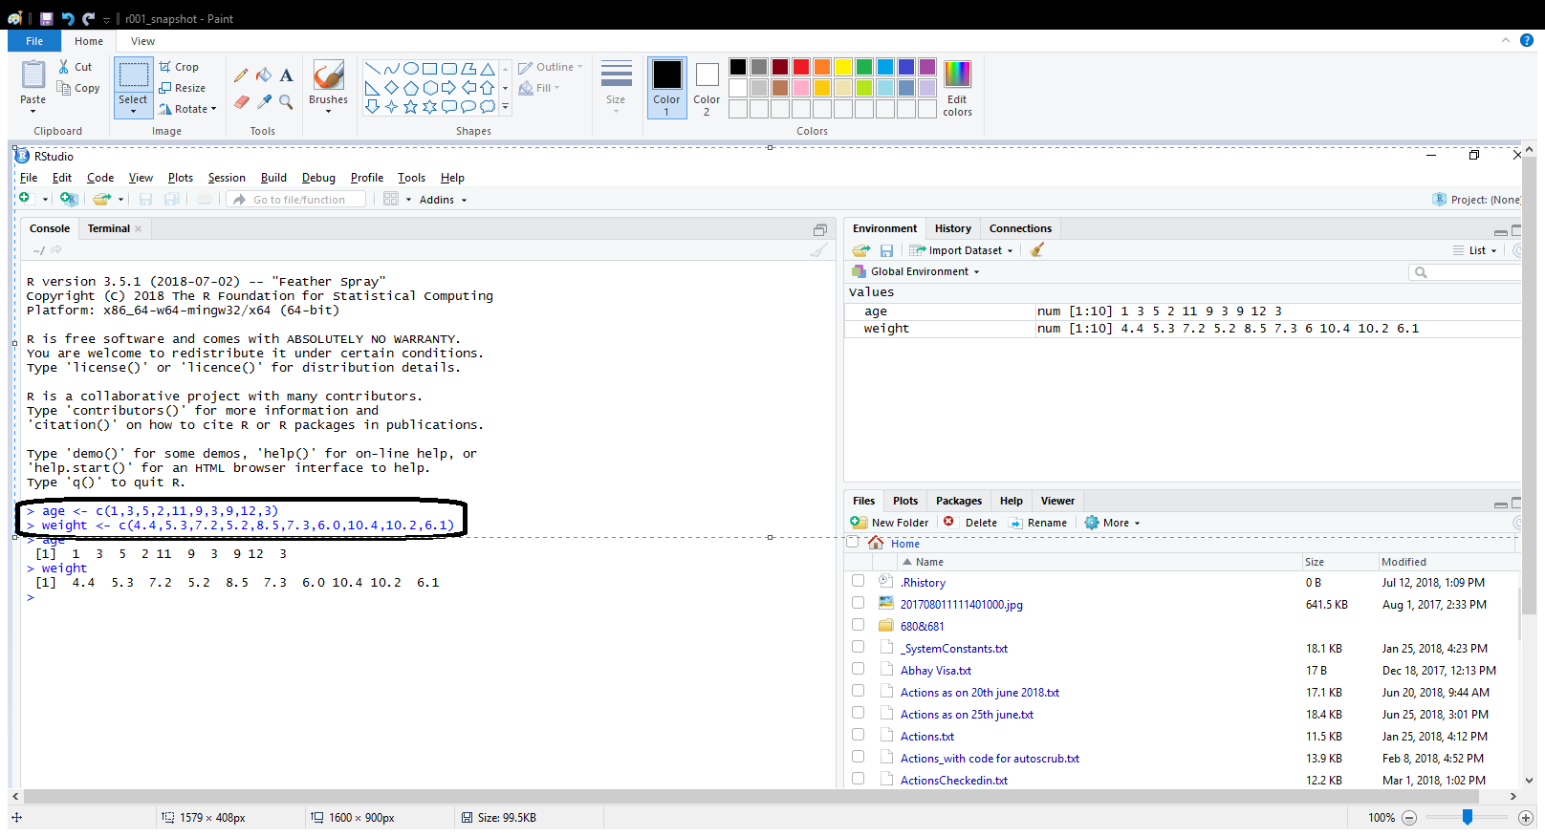

1. Use Ctrl + L to clear the screen
2. To display the vector ‘age’, just type age as follows.,

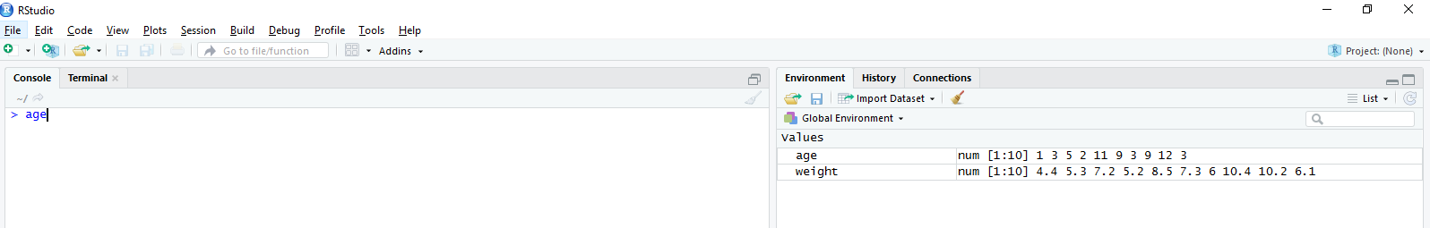

And the contents of the vector ‘age’ is displayed.

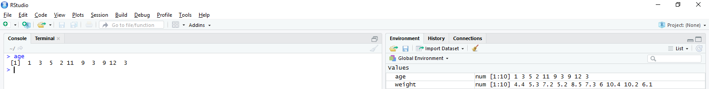

1. To display the vector ‘weight’, just type weight as follows.,

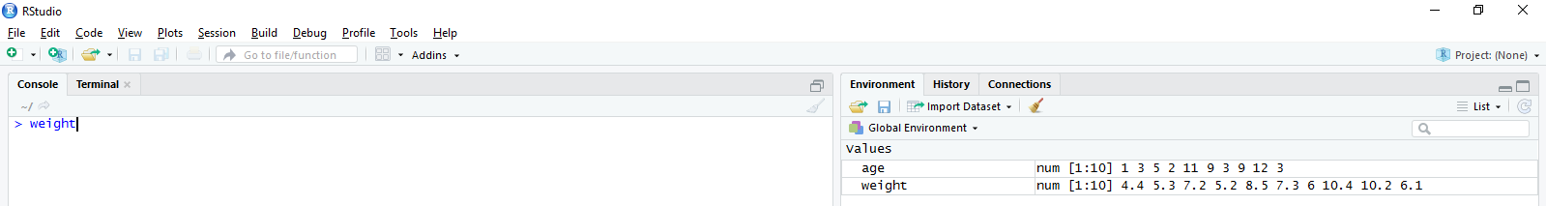

In addition, the contents of the vector ‘weight’ is displayed.

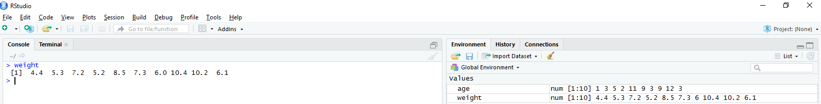

1. Calculating the mean for the given vector age and weight

Note: calling the mean function would be as follows

mean(age)

mean(weight)

Please remember that the function should be written in small letters.

What would happen if Mean(age) is calculated? Refer the snapshot below

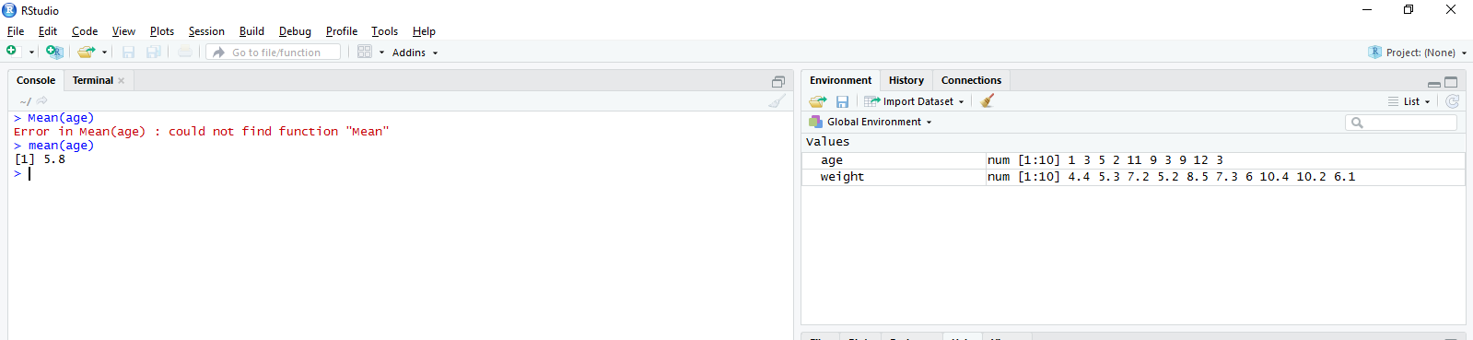

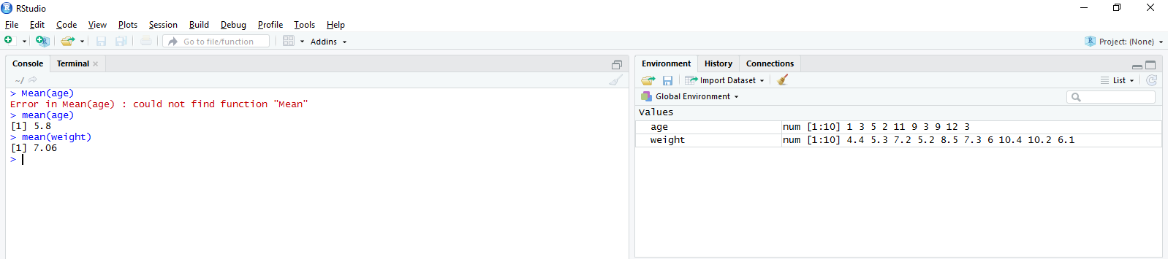

1. Calculate Standard Deviation for weight

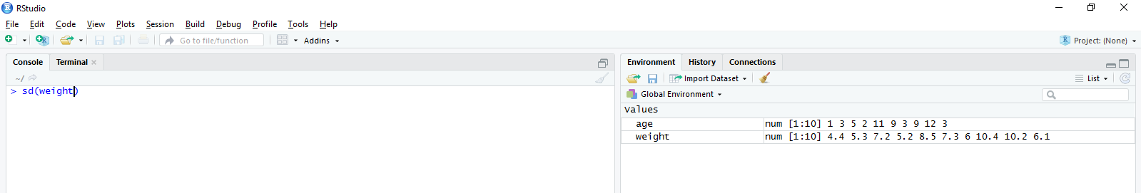

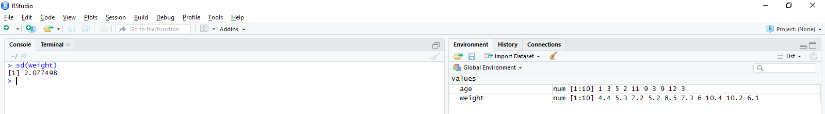

1. Find correlation between age and weight

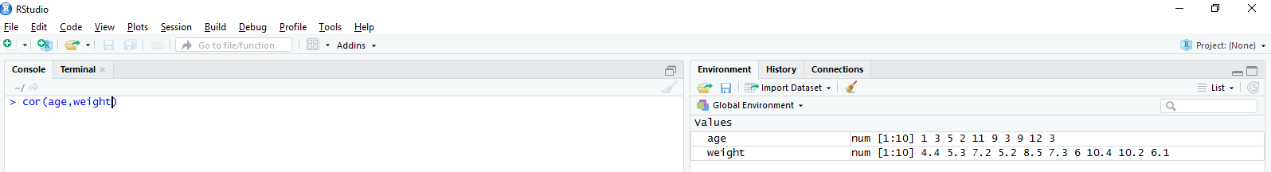

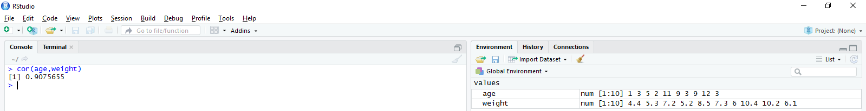

1. Try to plot a graph between these two vectors.